**Post Graduate Diploma in Water Hygiene and Sanitation (WASH)**

**WASH Assignment 3**

**Prepared by:**

S. M. Tareq Bin Jamil Neoaz

Email: [tareq.bin.jamil@gmail.com](mailto:tareq.bin.jamil@gmail.com)

Date of Submission: September 25, 2019

ASSIGNMENT

1. Explain six major non-domestic use of water.
2. Briefly describe the important roles that water plays in the human body.
3. List the types of people who are most vulnerable to waterborne diseases. Explain your answers why and how to overcome the diseases
4. Suppose that inhabitants of a village obtain water from a spring. What advice would you give to the users about the prevention of contaminants entering the spring?
5. The following are pollution sources. Give two specific pollutants for each source.
6. A residential area:
7. A metal plating plant:
8. Agricultural activities:
9. An uncontrolled landfill site:
10. Urban surface water run-off

**01. Explain six major non-domestic use of water**

### **Irrigation**

Irrigation water use includes water that is applied by an irrigation system to sustain plant growth in agricultural and horticultural practices. Irrigation also includes water that is used for pre-irrigation, frost protection, chemical application, weed control, field preparation, crop cooling, harvesting, dust suppression, and leaching salts from the root zone. Estimates of irrigation withdrawals are generally accounted for at the point of diversion (wells, springs, streams, ponds) and include water that is lost in conveyance prior to application on fields, as well as water that may subsequently return to a surface-water body as runoff after application, water consumed as evapotranspiration (ET) from plants and evaporated from the ground, or water that recharges aquifers as it seeps past the root zone.

|  |  |
| --- | --- |
|  |  |
| *Figure 1.1  An irrigation channel in Ethiopia.* | *Figure 1.2  Spray irrigation in a sugar cane plantation in the Finchaa Valley, Oromia Region.* |

### **Industrial use**

Industrial withdrawals provide water for such purposes as fabricating, processing, washing, diluting, cooling, or transporting a product; incorporating water into a product; or for sanitation needs within the manufacturing facility. Some industries that use large amounts of water produce such commodities as food, paper, chemicals, refined petroleum, or primary metals. Water for industrial use may be delivered from a public supplier or be self-supplied.

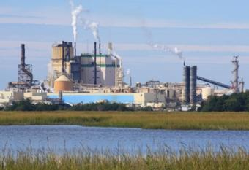

*Figure 1.3*Cellulose plant, Brunswick, Georgia

### **Mining use**

Mining water use is water used for the extraction of minerals that may be in the form of solids, such as coal, iron, sand, and gravel; liquids, such as crude petroleum; and gases, such as natural gas. The category includes quarrying, milling of mined materials, injection of water for secondary oil recovery or for unconventional oil and gas recovery (such as hydraulic fracturing), and other operations associated with mining activities. Dewatering is not reported as a mining withdrawal unless the water was used beneficially, such as dampening roads for dust control.

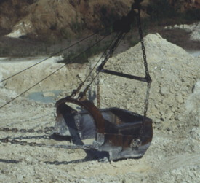

*Figure 1.4*Dragline bucket in kaolin mine

### **Use in power generation**

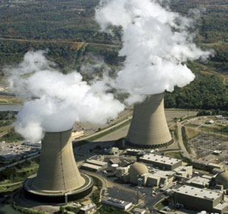Water for thermoelectric power is used in the process of generating electricity with steam-driven turbine generators. Since 2000, thermoelectric-power withdrawals have been compiled by cooling-system type. Once-through cooling refers to cooling systems in which water is circulated through heat exchangers, and then returned to the source. Recirculating cooling refers to cooling systems in which water is circulated through heat exchangers, cooled using ponds or towers, and then recirculated. Subsequent water withdrawals for a recirculating system are used to replace water lost to evaporation, blowdown, drift, and leakage. Prior to 2000, thermoelectric-power withdrawals were compiled by fuel type (fossil-fuel, nuclear, and geothermal). Thermoelectric power cooling water sources include fresh and saline water from both surface-water and groundwater sources. Reclaimed wastewater is a supplemental source of water for thermoelectric power, especially in areas where additional water sources are needed for plant operations.

*Figure 1.5*Aerial photo of Beaver Valley Power Station in Pennsylvania, showing evaporation from the large cooling towers.

### **Aquacultural use**

Aquaculture water use is water associated with raising organisms that live in water—such as finfish and shellfish—for food, restoration, conservation, or sport. Aquaculture production occurs under controlled feeding, sanitation, and harvesting procedures primarily in ponds, flow through raceways, and, to a lesser extent, cages, net pens, and closed-recirculation tanks.

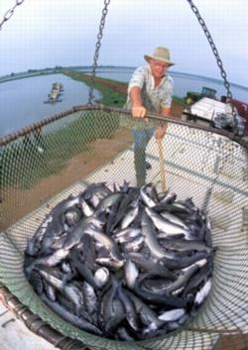

*Figure 1.6*Paul Wilson guides a basket containing 2,000 pounds of catfish into a transport truck

# **Livestock Water Use**

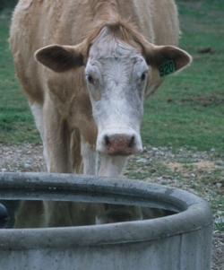Livestock water use is water associated with livestock watering, feedlots, dairy operations, and other on-farm needs. Livestock includes dairy cows and heifers, beef cattle and calves, sheep and lambs, goats, hogs and pigs, horses, and poultry. Other livestock water uses include cooling of facilities for the animals and products, dairy sanitation and wash down of facilities, animal waste-disposal systems, and incidental water losses. The livestock category excludes on-farm domestic use, lawn and garden watering, and irrigation water use.

*Figure 1.7*Cow at water tank, Lamar County, Georgia.

**02. Briefly describe the important roles that water plays in the human body**

Water makes up a majority of body weight and is involved in many important functions, including:

* flushing out waste from body
* regulating body temperature
* helping brain function

We get most of your water from drinking beverages, but food also contributes a small amount to daily water intake.

Water is a main component of saliva. Saliva also includes small amounts of electrolytes, mucus, and enzymes. It’s essential for breaking down solid food and keeping mouth healthy.

Body generally produces enough saliva with regular fluid intake. However, saliva production may decrease as a result of age or certain medications or therapies.

Staying hydrated is crucial to maintaining body temperature. Body loses water through sweat during physical activity and in hot environments. Sweat keeps body cool, but body temperature will rise if don’t replenish the water you lose. That’s because body loses electrolytes and plasma when it’s dehydrated.

Water consumption helps lubricate and cushion your joints, spinal cord, and tissues. This will help you enjoy physical activity and lessen discomfort caused by conditions like arthritis.

It helps excrete waste through perspiration, urination, and defecation

Body uses water to sweat, urinate, and have bowel movements.

Sweat regulates body temperature when you’re exercising or in warm temperatures.

Also need enough water in body to have healthy stool and avoid constipation. Kidneys are also important for filtering out waste through urination. Adequate water intake helps your kidneys work more efficiently and helps to prevent kidney stones.

Drinking water before, during, and after a meal will help your body break down the food you eat more easily. This will help you digest food more effectively and get the most out of your meals.

In addition to helping with food breakdown, water also helps dissolve vitamins, minerals, and other nutrients from your food. It then delivers these vitamin components to the rest of your body for use.

Water carries helpful nutrients and oxygen to your entire body. Reaching your daily water intake will improve your circulation and have a positive impact on your overall health.

Summary:

Over half the human body is water, which is essential for the correct functioning of virtually all living cells. The body has developed mechanisms to maintain water balance under conditions of mildly fluctuating availability and generally, consumption of 1.5L of liquid per day is sufficient, in conjunction with the liquid ingested as a component of food, to replace the water lost throughout the day. However, the mechanisms do not trigger the sensation of needing to drink until there is already a water deficit. In normal circumstances in temperate climates this does not matter, but athletes, the young, the elderly and those working in hot climates have to take special steps to ensure they drink regularly and before they feel thirsty. As with all food, variety is good because the drinks supply other useful components of the diet in addition to water. While the rate of rehydration is rarely important in temperate climates, in circumstances where it does matter, such as in some illnesses, the addition of carbohydrate and salt has been shown to improve the rate of transfer of water from the gut into the body.

**03. List the types of people who are most vulnerable to waterborne diseases. Explain your answers why and how to overcome the diseases**

Water is one of the most important requirements for human health and life. It’s the most effective carrier of pathogens causing a number of infectious diseases in developing countries particularly in rural areas.

Globally, at least 2.1 billion people use a drinking water sources contaminated with feaces. Contaminated water and poor sanitation are linked to transmission of diseases such as diarrhoea, cholera, dysentery, typhoid and polio.

Children below 5 years of age and females are more vulnerable to waterborne diseases.

Female are more vulnerable to skin infection, diarrhoea and gastroenteritis, typhoid, dysentery as well as cholera. Women and children are most susceptible to water borne disease due to their roles in water collection, clothes washing and other domestic activities. Women are also responsible for the care of sick family members. Also females were more prone to waterborne diseases as compared to males. The three most contagious diseases are typhoid, dysentery, and cholera which fortunately contribute least distribution of waterborne diseases. These diseases can spread and affect large mass of the population within a short time causing drastic impacts.

Waterborne diseases according to different age groups that within 0-5 age groups are more vulnerable to waterborne diseases. This is because their immune systems are not well developed. Going by the findings of lack of safe drinking water makes children more vulnerable to disease. Their immune systems and detoxification mechanisms are not fully developed, so they often due less able to respond to a water-related infection.

Waterborne diseases are more prevalent in rainy season than dry season. To overcome disease, it is essential to improve sanitation facilities, hygiene and access to safe and adequate drinking water.

**04. Suppose that inhabitants of a village obtain water from a spring. What advice would you give to the users about the prevention of contaminants entering the spring?**

Whether the spring originates from shallow or deep rock layers, animals should be excluded from the surrounding area by a stock-proof fence. Springs should be protected from flooding and surface water pollution by constructing a deep diversion ditch above and around the spring. The ditch should be constructed so that it collects surface water running towards the spring and carries or diverts it away. It needs to be deep enough to carry all surface water away, even in a heavy rainstorm.

There may not be many opportunities to develop new spring sources but, if the opportunity does arise, there are certain procedures to follow to ensure the spring water is protected and safe to drink. You would be working with others if a new spring source was to be developed but the same principles will apply to existing spring sources because the protection needs to continue to work into the future.

A spring is protected by providing a concrete headwall or spring box around the eye of the spring (where water emerges) that prevents direct contamination (WHO, 1997; Howard et al., 2001; Meuli and Wehrle, 2001). There are a number of designs for protected springs, all of which utilize some form of retaining wall or spring box with an excavated area backfilled with loose material to encourage spring flow towards the outlet. A protective cover usually overlies the excavated area and the area is fenced for some distance to prevent direct access by humans and animals. One design that has been used in peri urban areas is shown in Figure.



**Figure .** Cross-section of the backfill of a protected spring (Howard *et al.,* 2001)

Where protection is poor, contamination may occur at the point of emergence due to recharge by contaminated water in the immediate area. Thus the proper protection of the spring eye becomes vital. At most springs, the eye of the spring is excavated and the area backfilled with loose material. The filter media should be sufficiently fine to provide reasonable filtration of the groundwater entering from the spring eye and any surface water percolating through the immediate area: usually gravel although finer media may be required in more polluted areas.

**05. The following are pollution sources. Give two specific pollutants for each source.**

a) A residential area: Nitrates and phosphates

b) A metal plating plant: Zinc and Lead

c) Agricultural activities: Nitrates and phosphates

d) An uncontrolled landfill site: leachate, Litter

e) Urban surface water run-off: Sediments and suspended solids

**Reference:**

1. Thirst: or, why do people drink? Correspondence: Mr Mike Saltmarsh Director, Inglehurst Foods, 53 Blackberry Lane, Four Marks, Alton, Hants GU34 5DF, UK. Tel.: + 44 1420 563413; e‐mail: [inglehurst.foods@btinternet.com](mailto:inglehurst.foods@btinternet.com)
2. Why Is Water Important? 16 Reasons to Drink Up, medically reviewed by Natalie Butler, RD, LD on March 19, 2019 — Written by Natalie Silver
3. Prevalence of Waterborne Diseases in Relation to Age and Gender in Nakoloke Sub County Mbale District, Uganda. Nafiu Abdulkadir, H. M Usman, and Mustapha G, Department of Microbiology, Sokoto State University, Along Airport Road, Sokoto, Nigeria.
4. Water Safety Plans: Risk management approaches for the delivery of safe drinking-water from groundwater sources - G. Howard and O. Schmoll
5. PGD WASH module -3